***Docker Exercise………….***

2. Find a image from dockerhub of your choice(recommeded: nginx), don't use browser, pull the official image from dockerhub

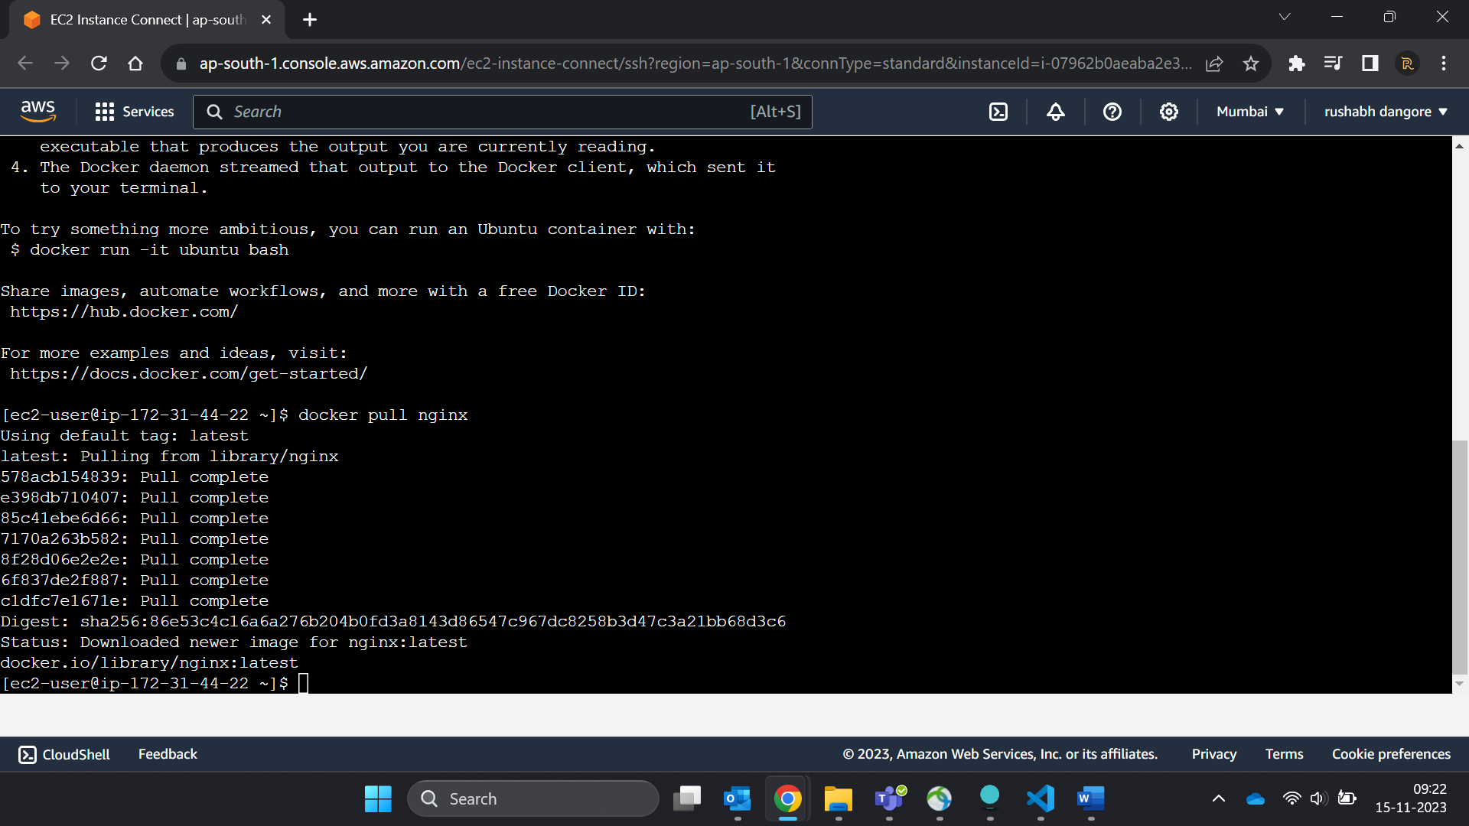  
3. List all the available images in your machine/vm, make sure you see recently pulled image in the list.

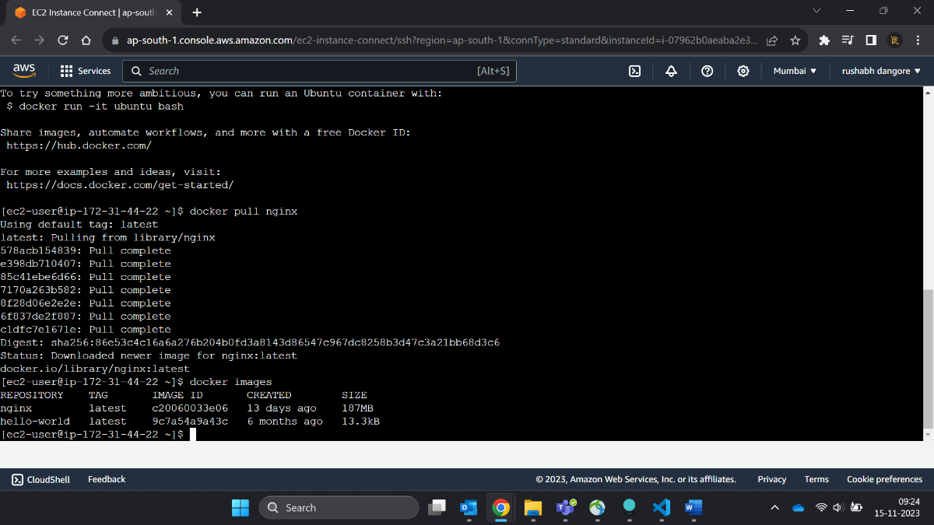  
4. Find out the "Full" ImageId of the image that you pulled and write it below.

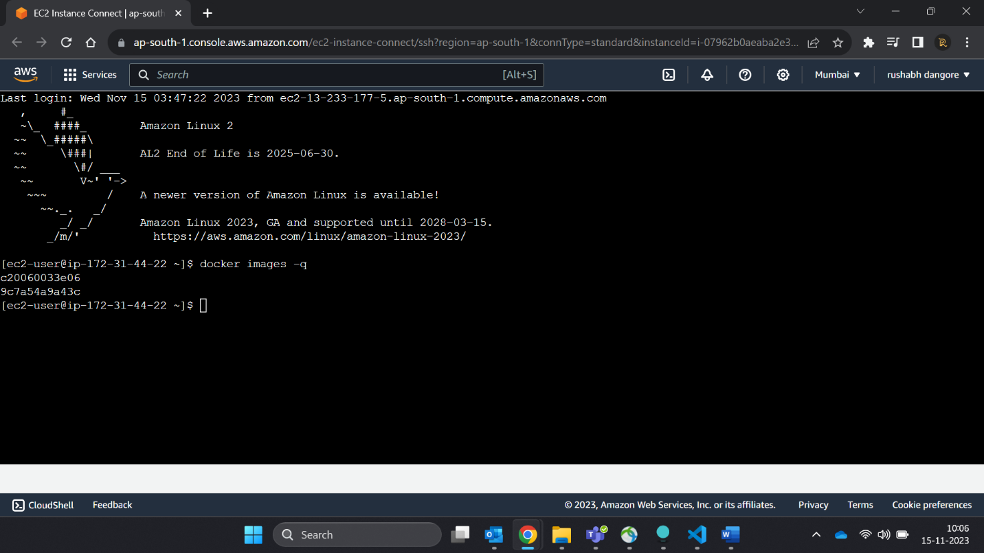

5. Create a container of your image

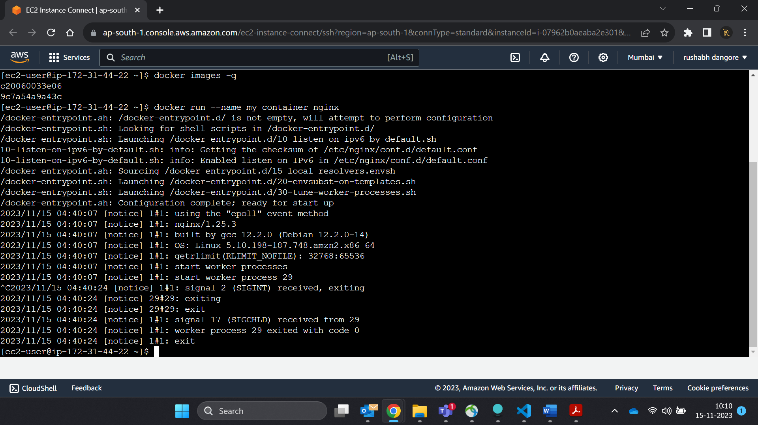

6. List all the running containers  
7. List all the running and stopped containers

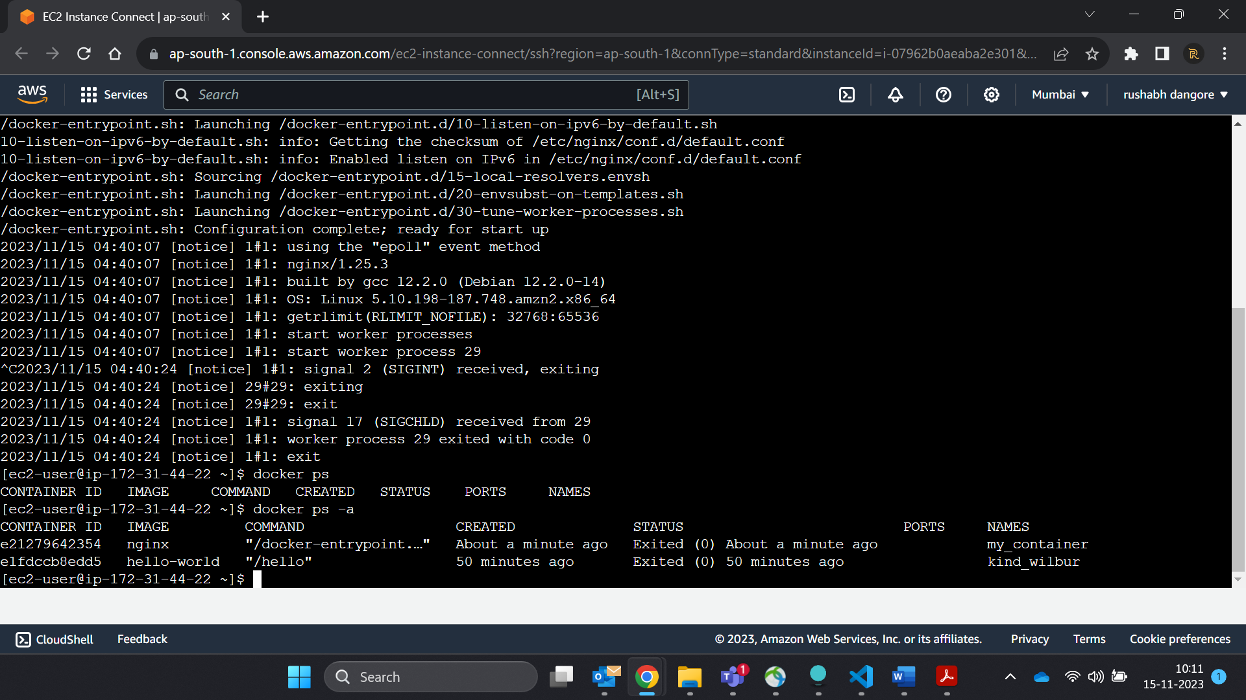

8. Find out the "Full" containerId of the container and write it below.

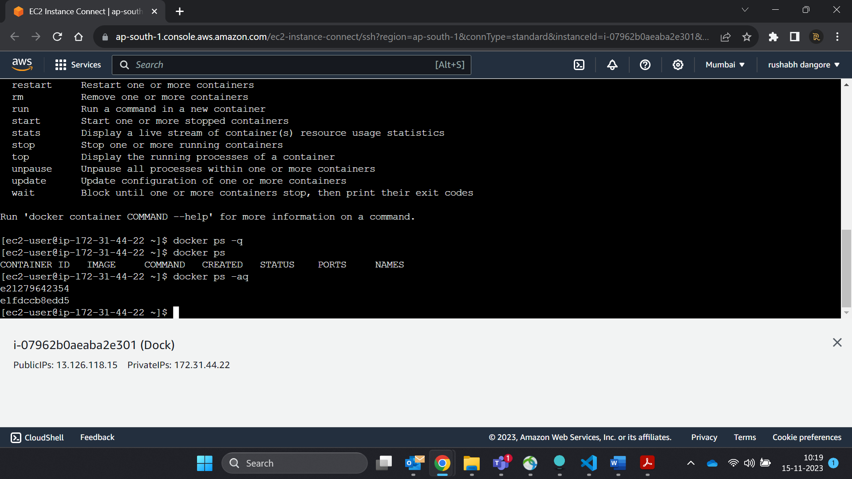

9. Find out how many image layers are used to build this image.

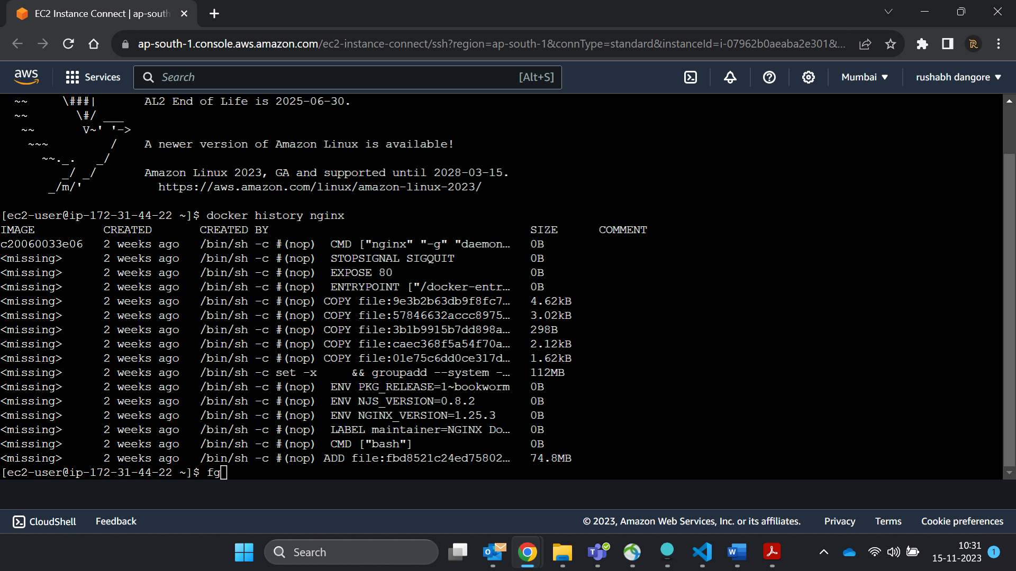

10. Get the Apache Tomcat 7 server image from the docker hub.

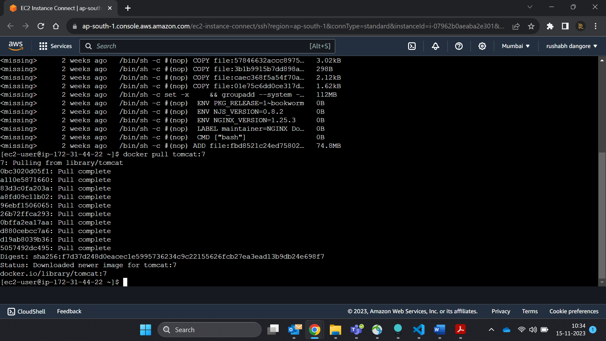

11. Run the Apache Tomcat 7, I mean create a container of Apache Tomcat.

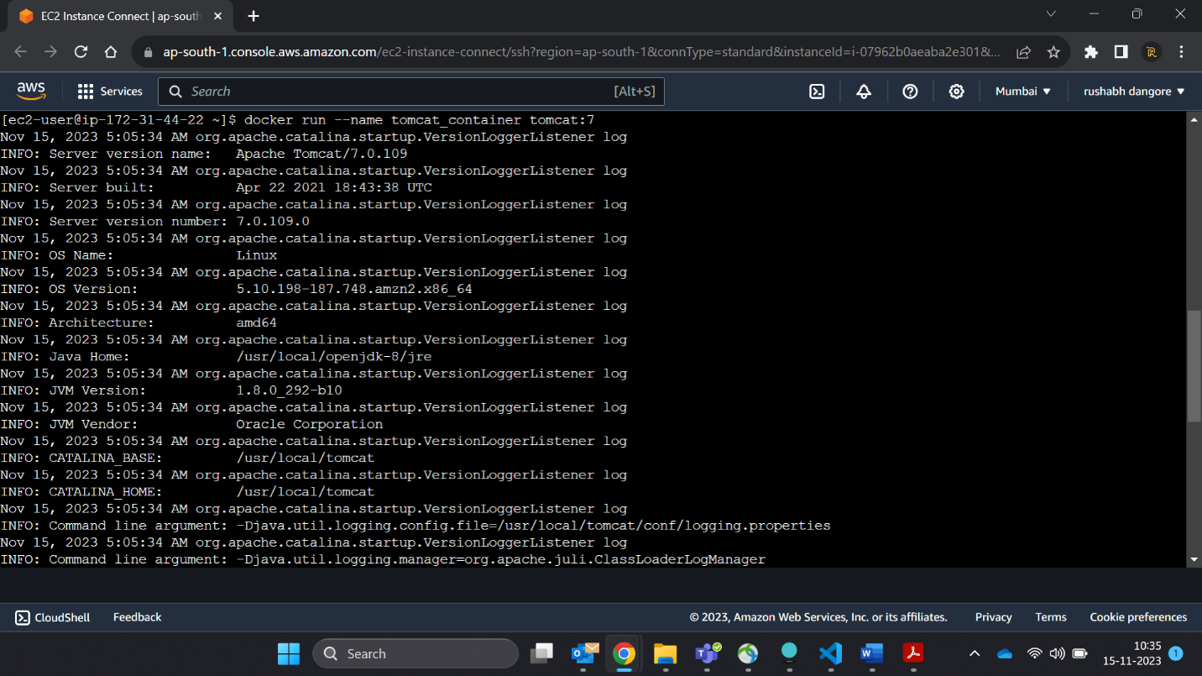

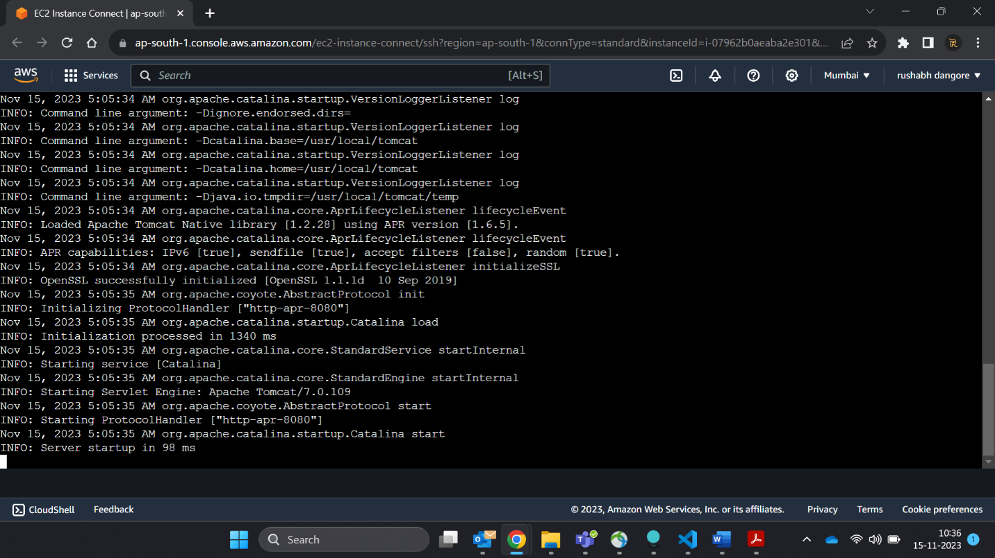

12. Find out what is the IP Address of the Apache Tomcat Container that it is running on  
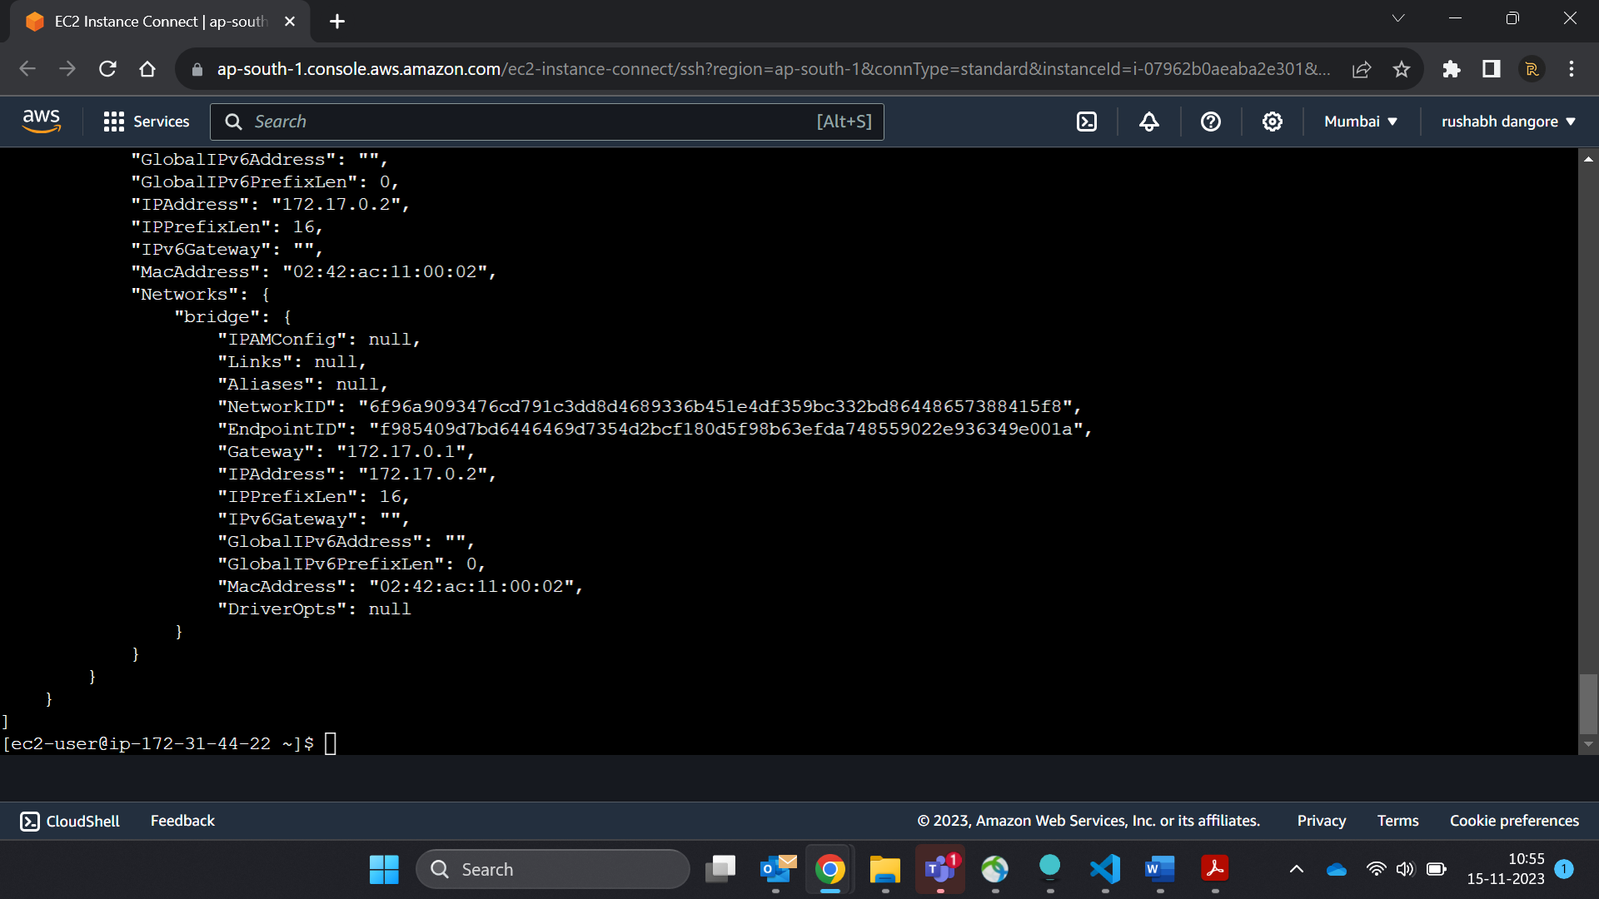

13. Which Port it is using?

14. Try to access the Tomcat's home page from your machine/vm.  
15. What is the disk size of Apache Tomcat image?

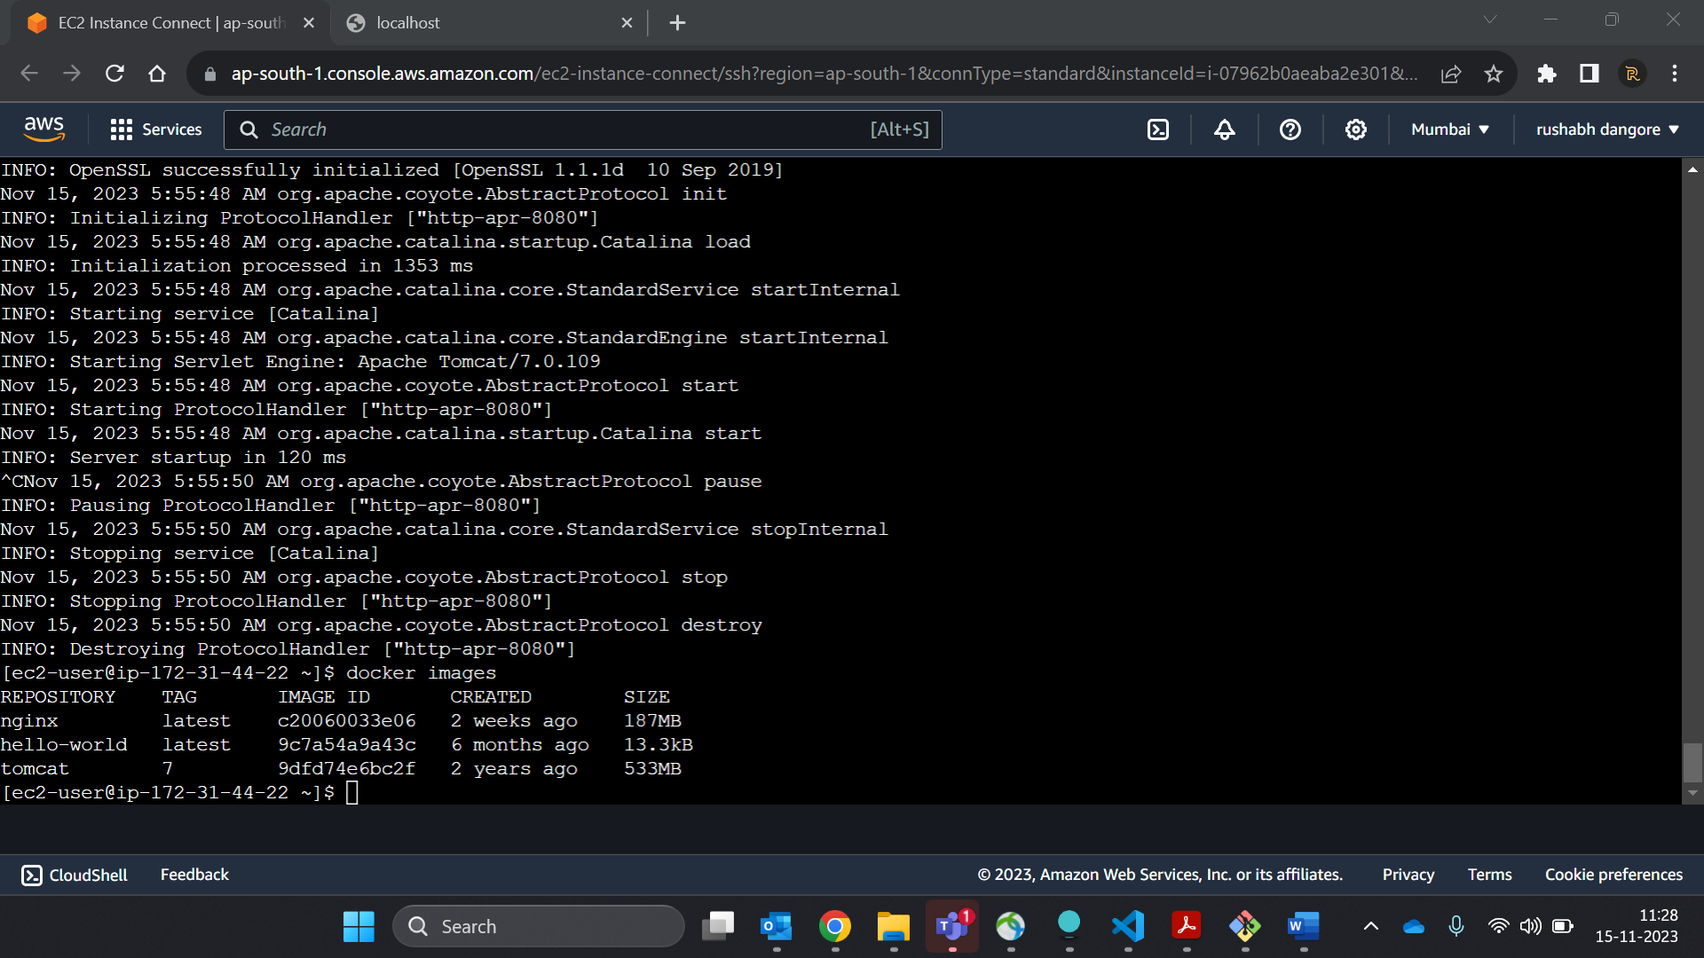

16. Find out list of all environment variables that is configured for tomcat image, can you see

JAVA_HOME and CATALINA_HOME? What did you notice about it?

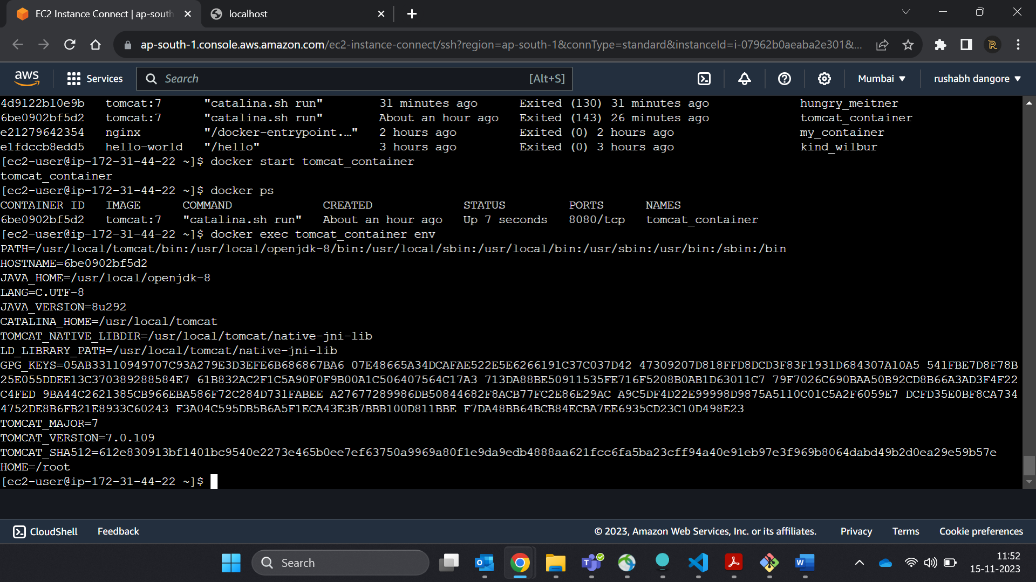

17. Find out which port is exposed for tomcat?

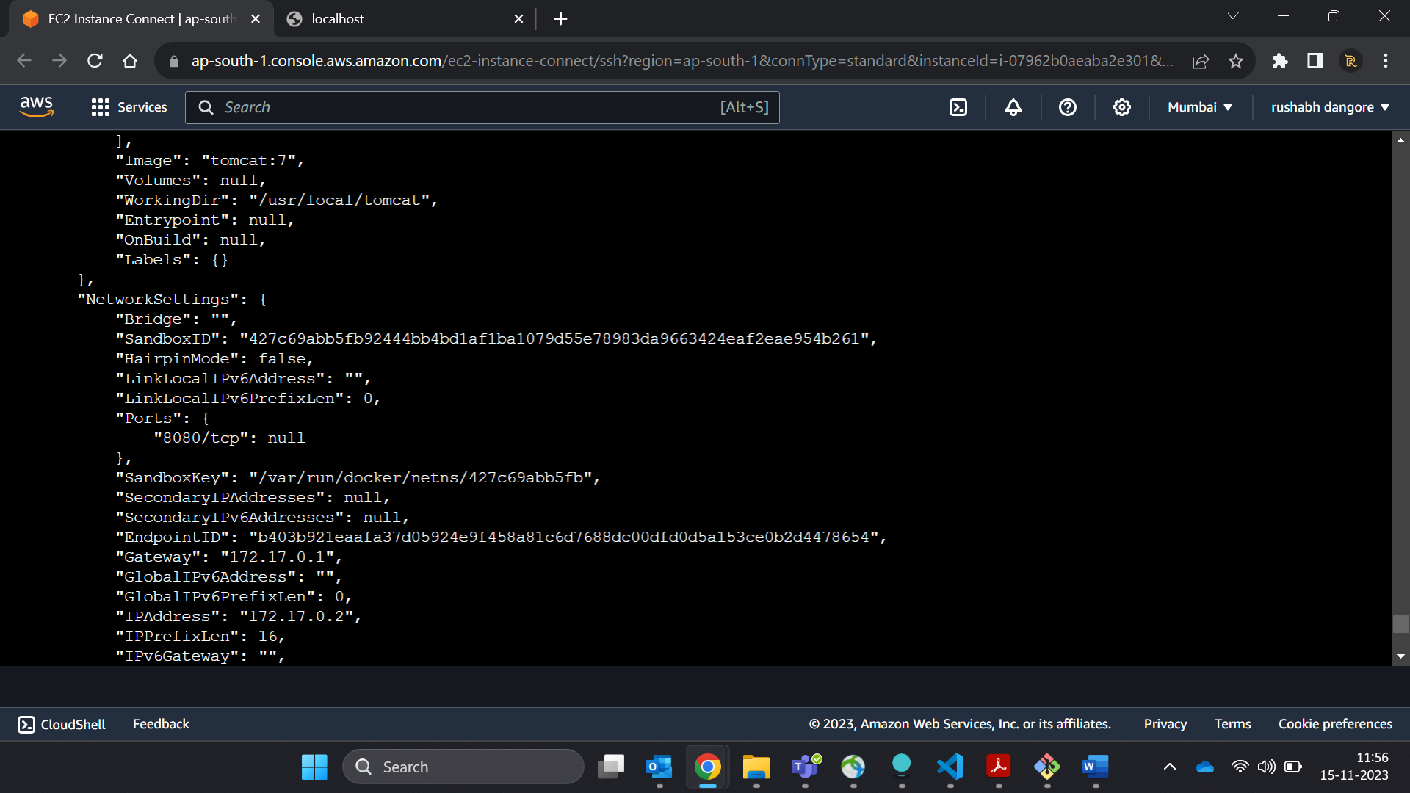

18. Run multiple conntainers of tomcat on different port and access it's home page.  
19. Pull ubuntu os from dockerhub, try to pull 2 images of ubuntu, Except the latest one.

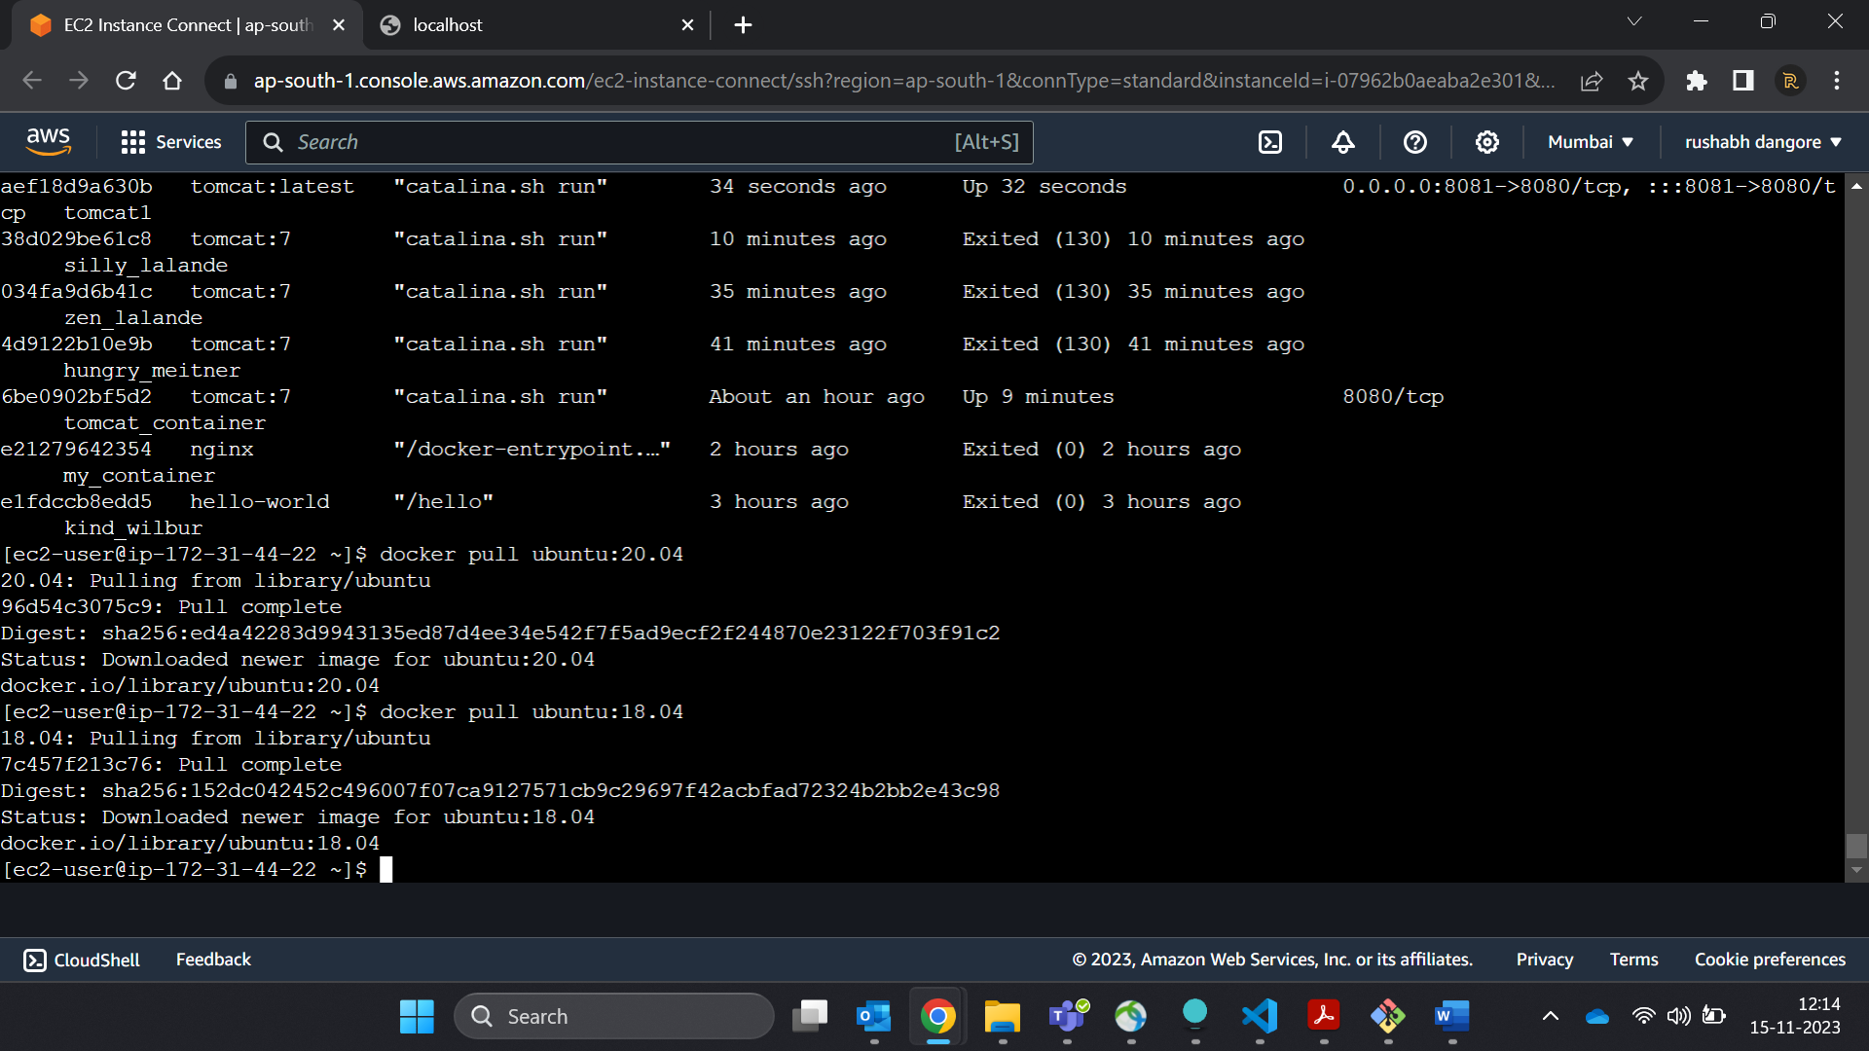

20. Run the container of ubuntu in attached mode.

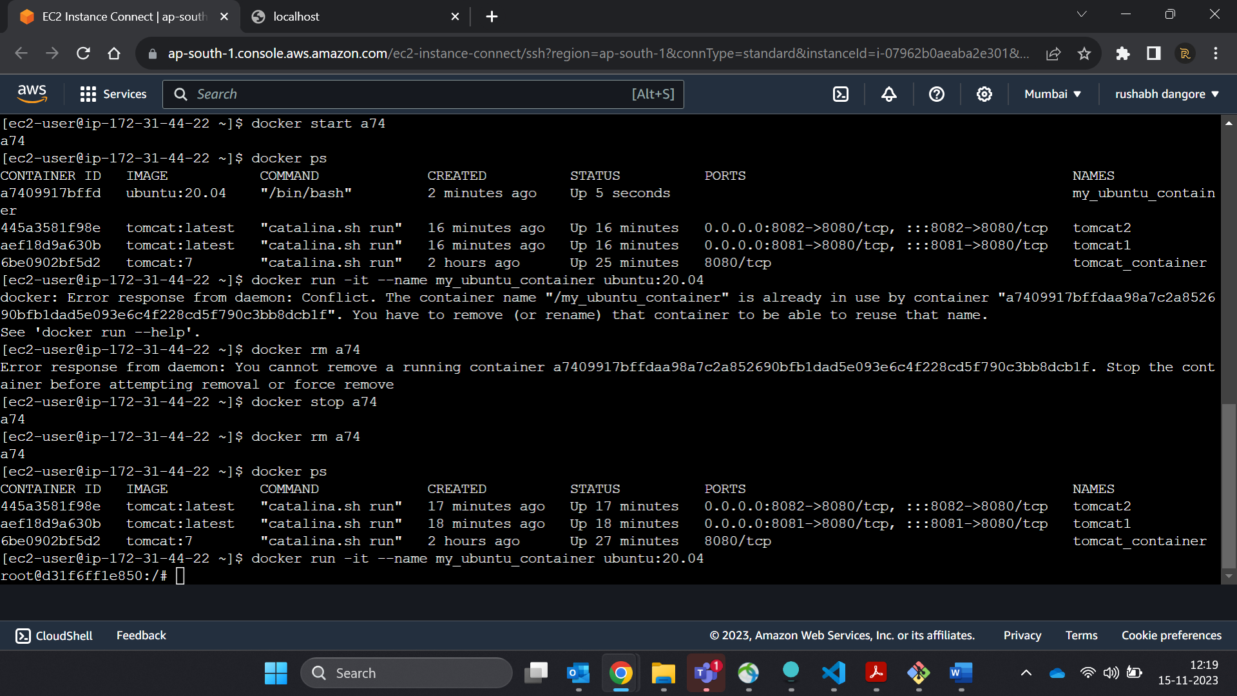  
21. Run the container of another ubuntu in detached mode.  
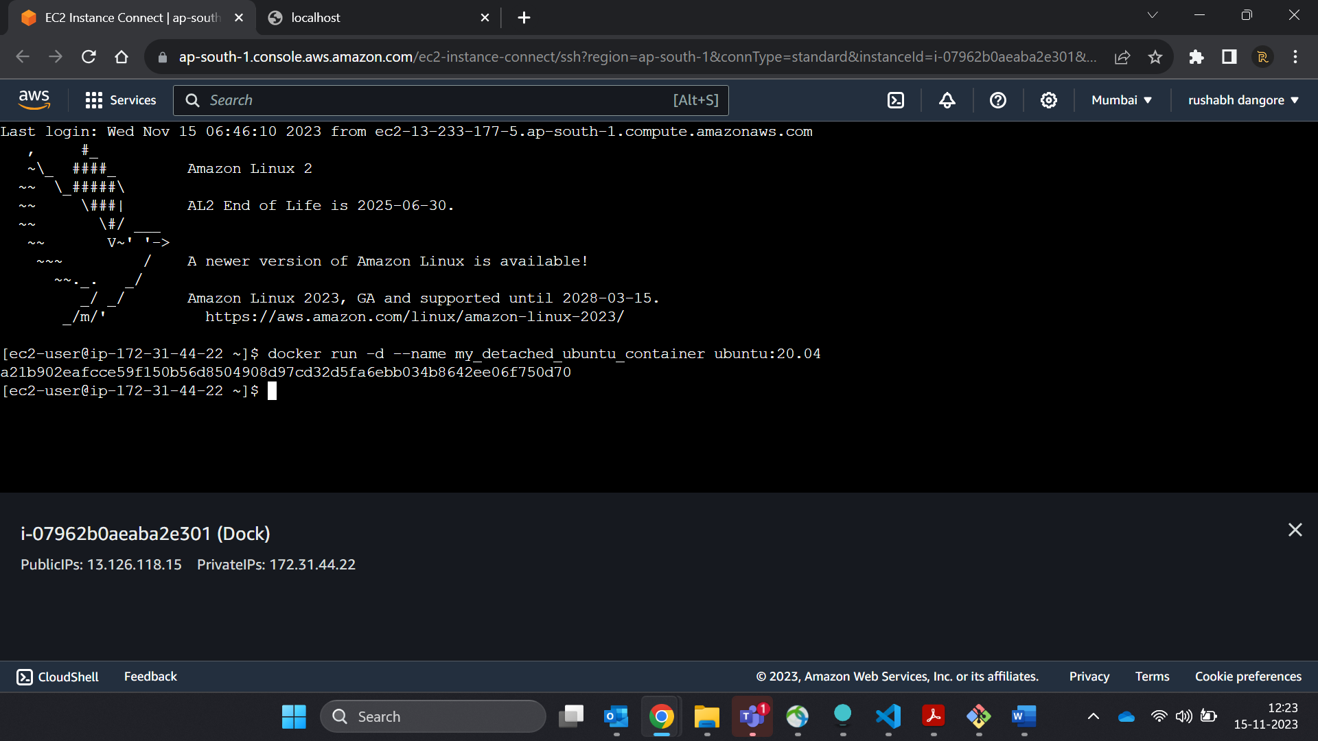

22. Check how many ubuntu containers are running and stopped

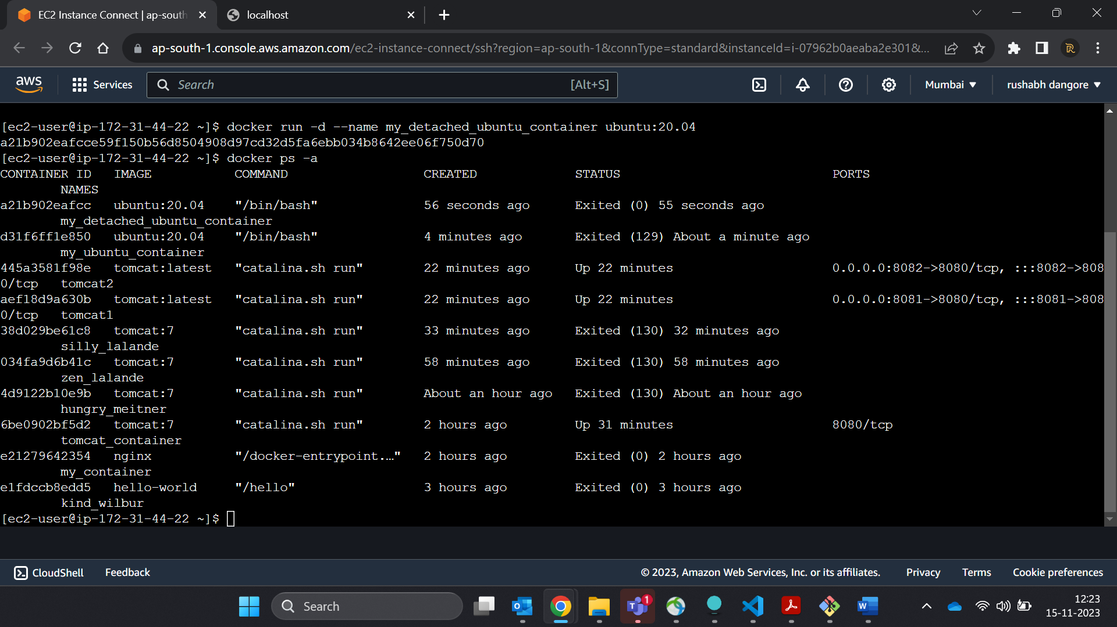  
23. Is the tomcat container running? If no, start one.

--yes its running

  
24. Check the logs, generated by tomcat container(don't forget to make request to tomcat's home page to see the log).

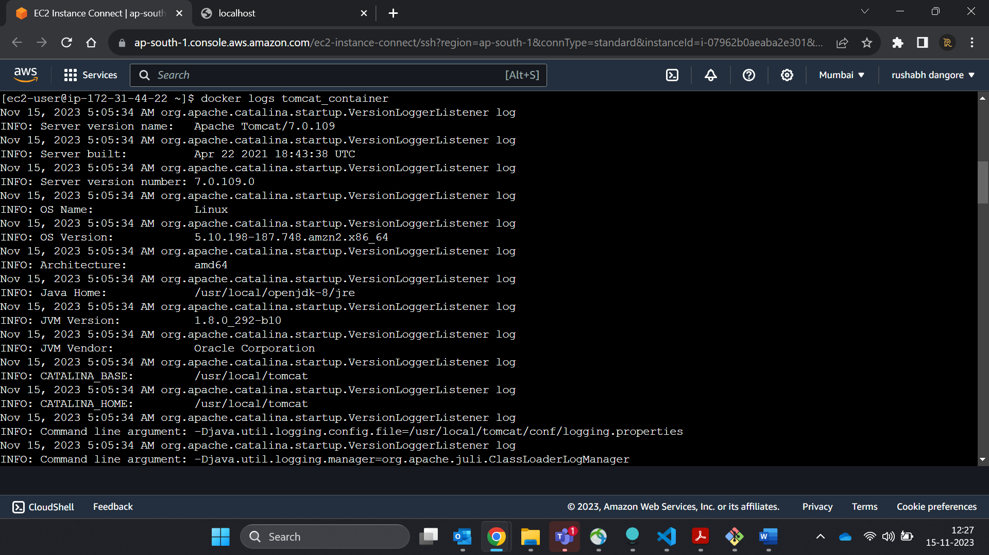

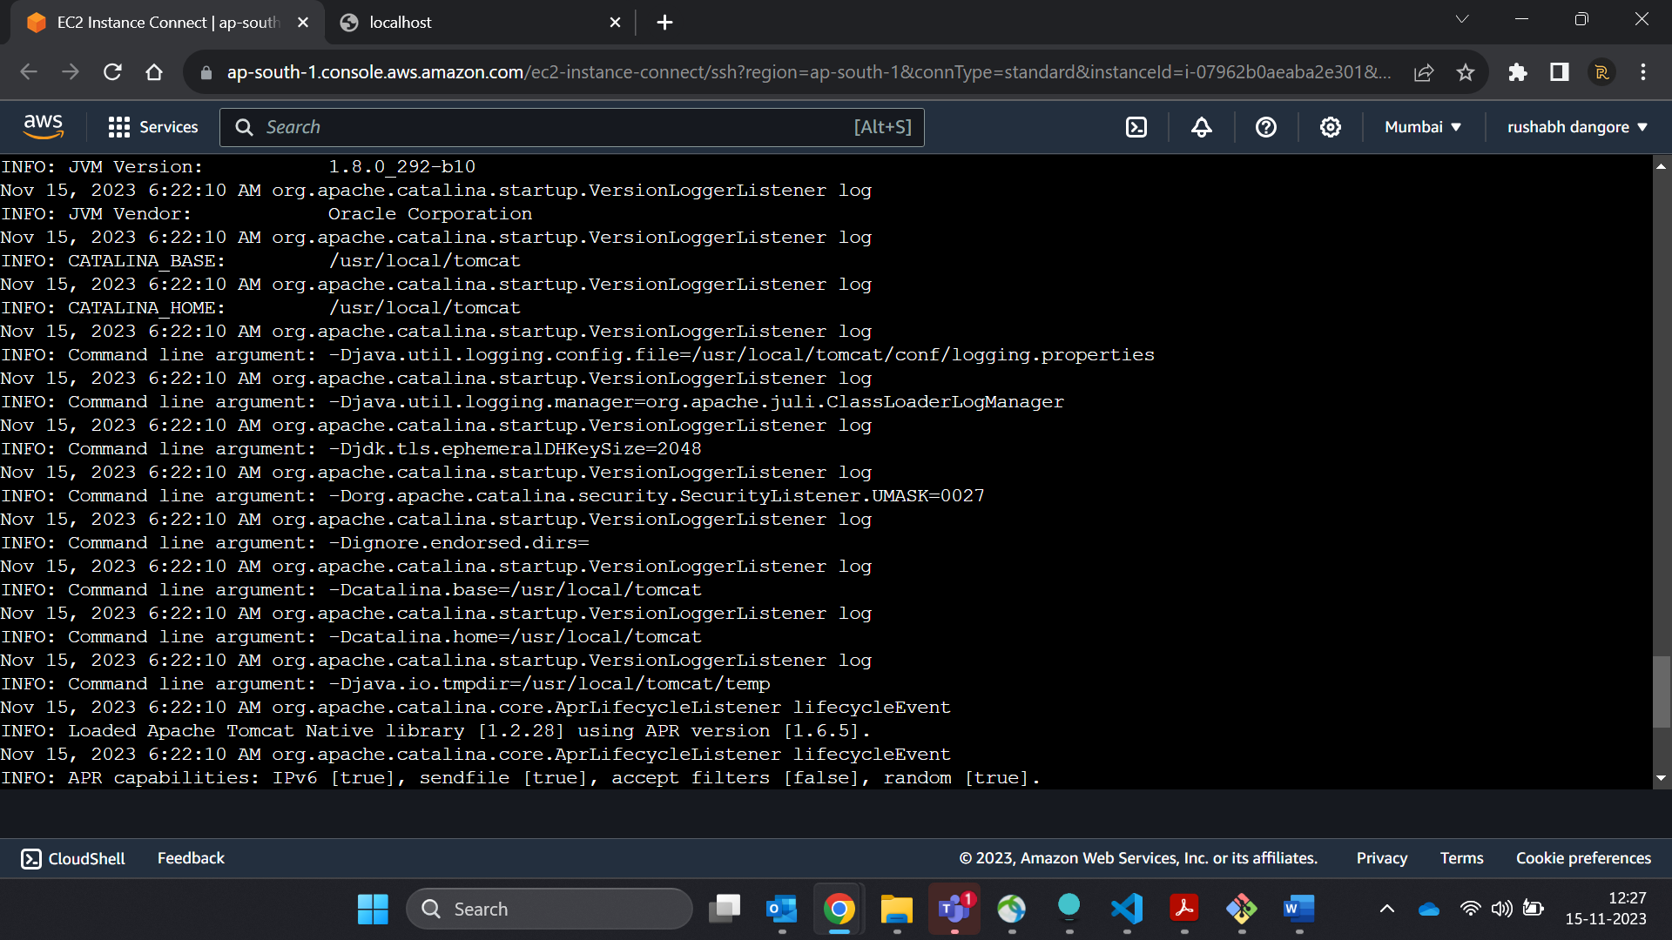

25. Check if ubuntu conatiner is running? If no, start one in attached mode to the terminal.

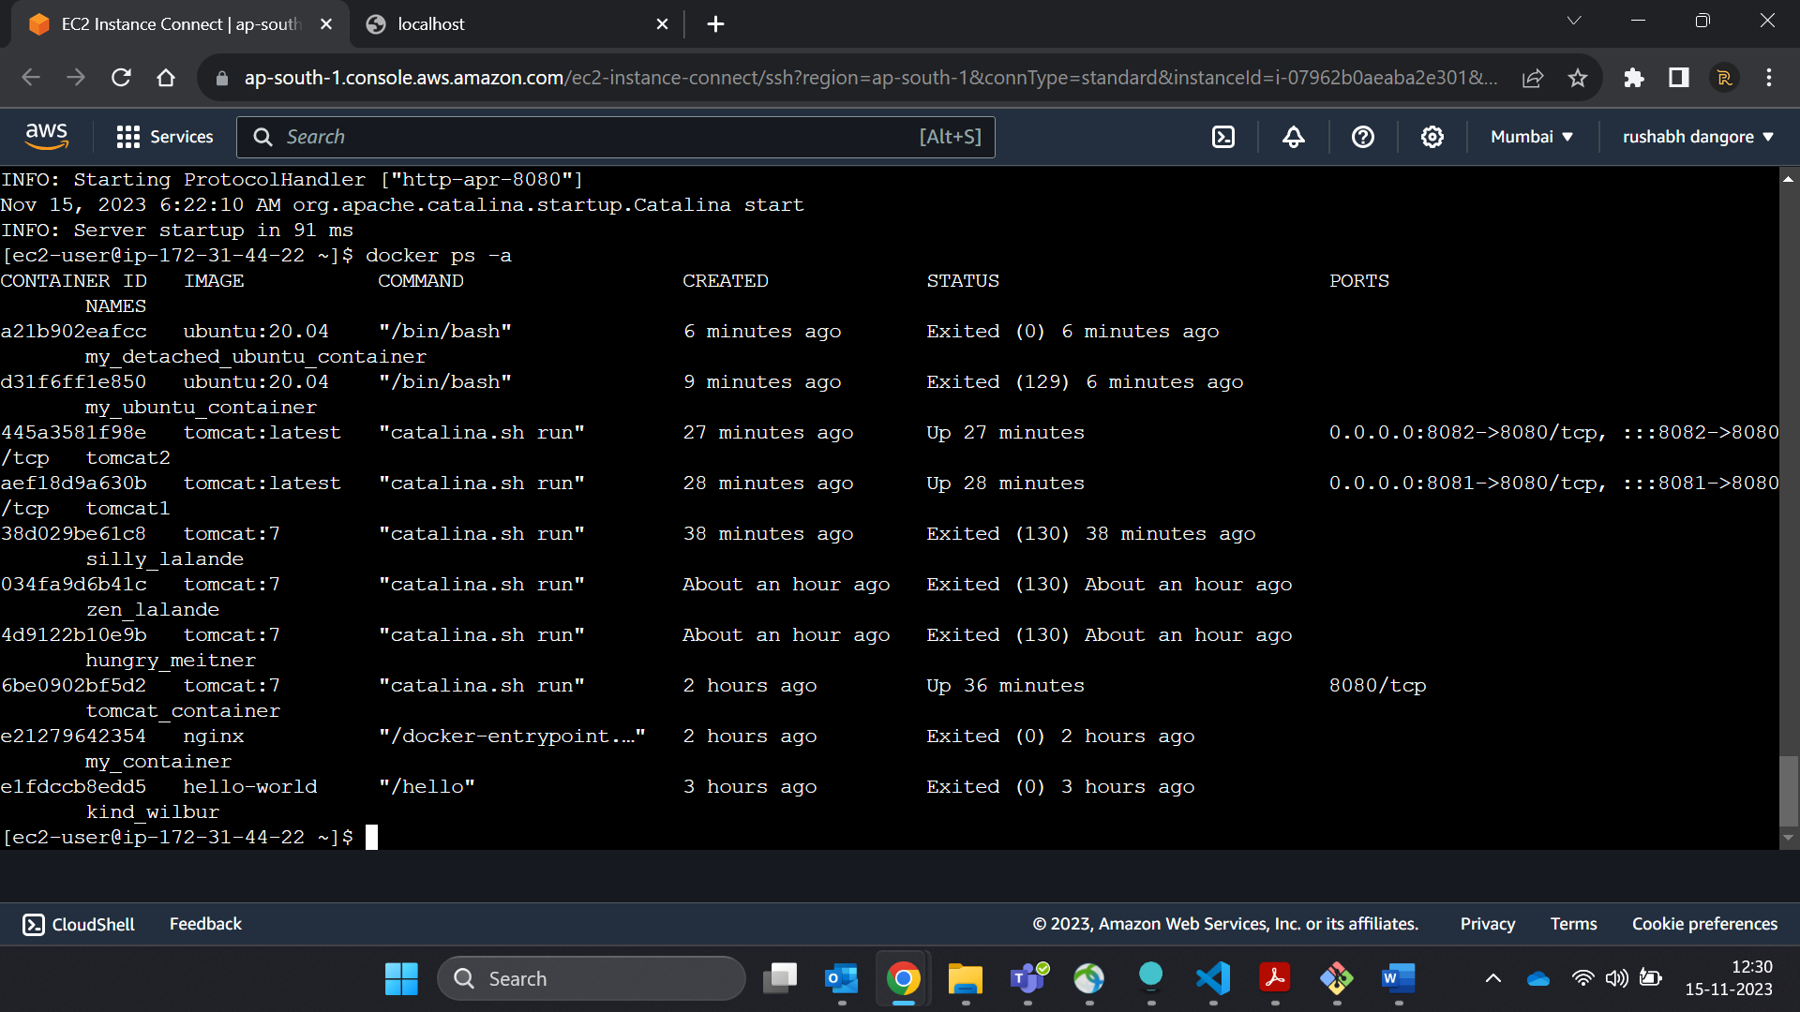

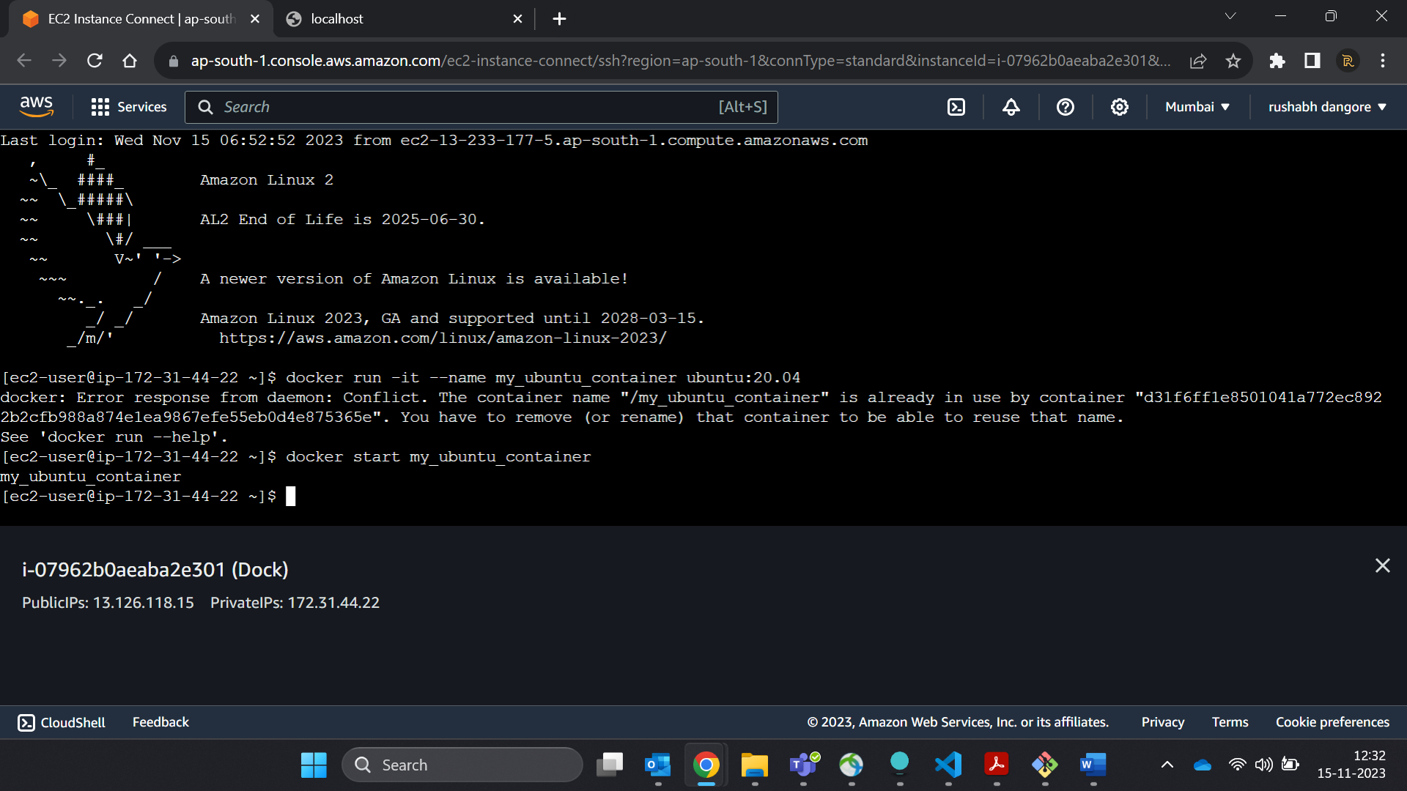

26. Login as root user in ubuntu container

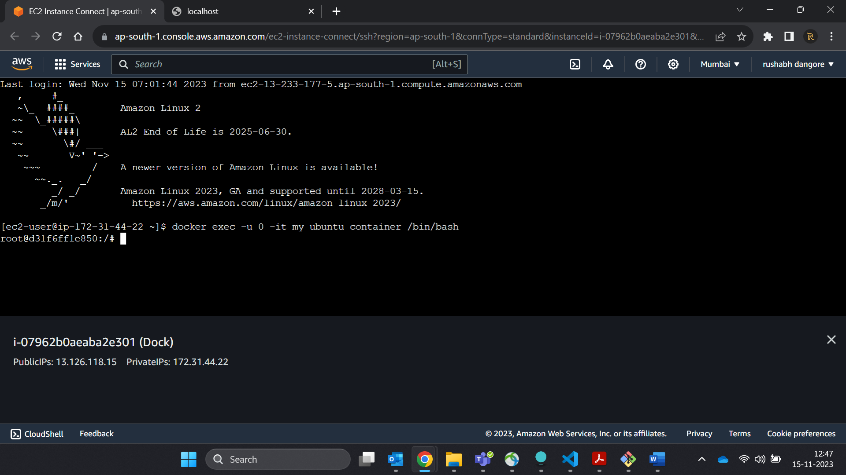

27. Create a file with any name in root directory

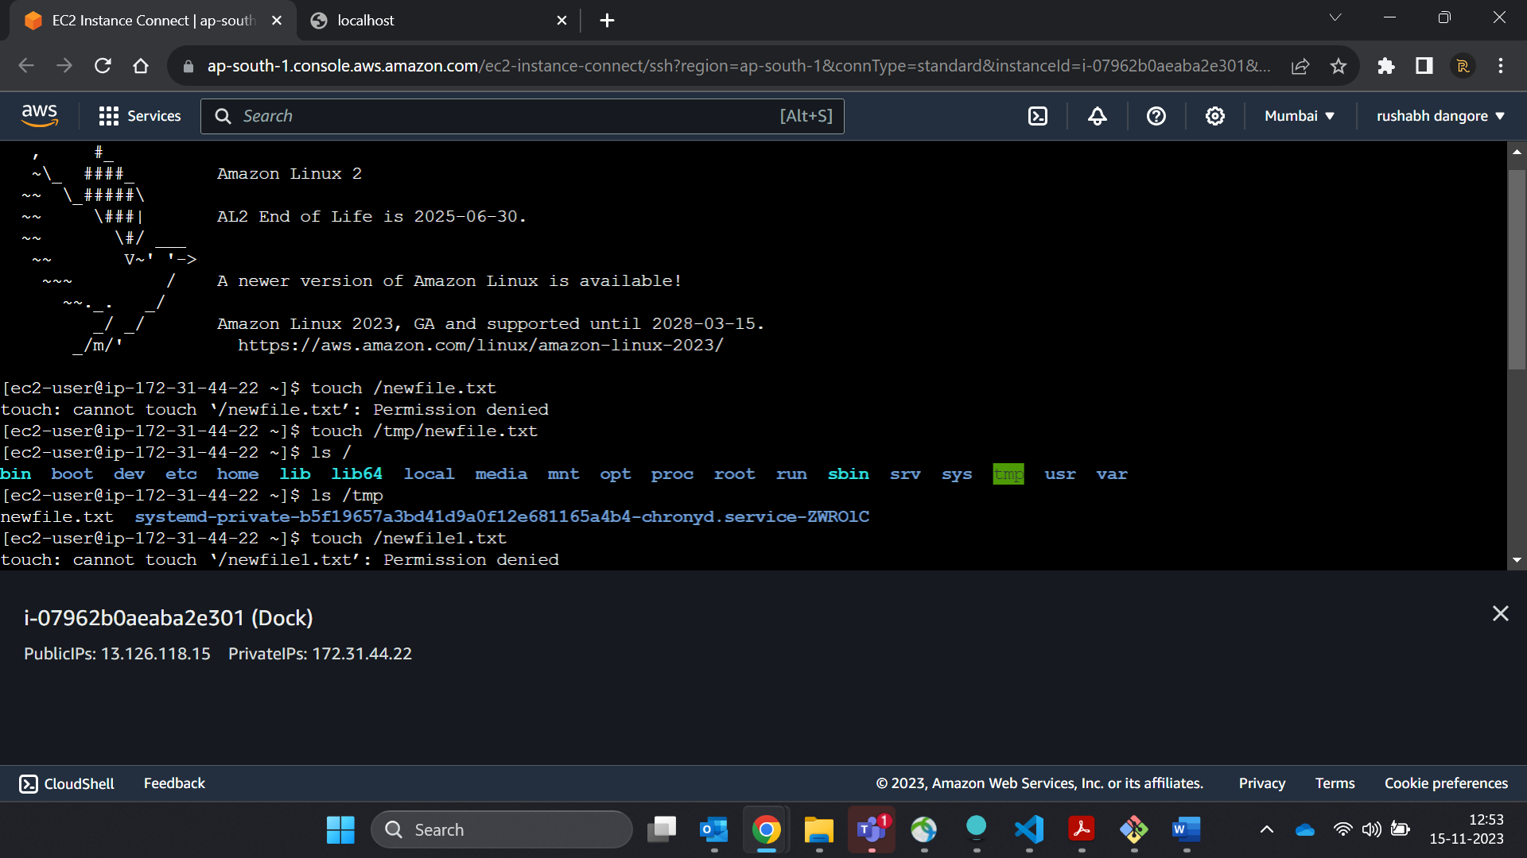

28. Install software of your choice in ubuntu container using "apt-get install"

29. Now exit the ubuntu shell, are you back to your host machine, if not, come back to the host machine.  
30. Check if the ubuntu container is running.

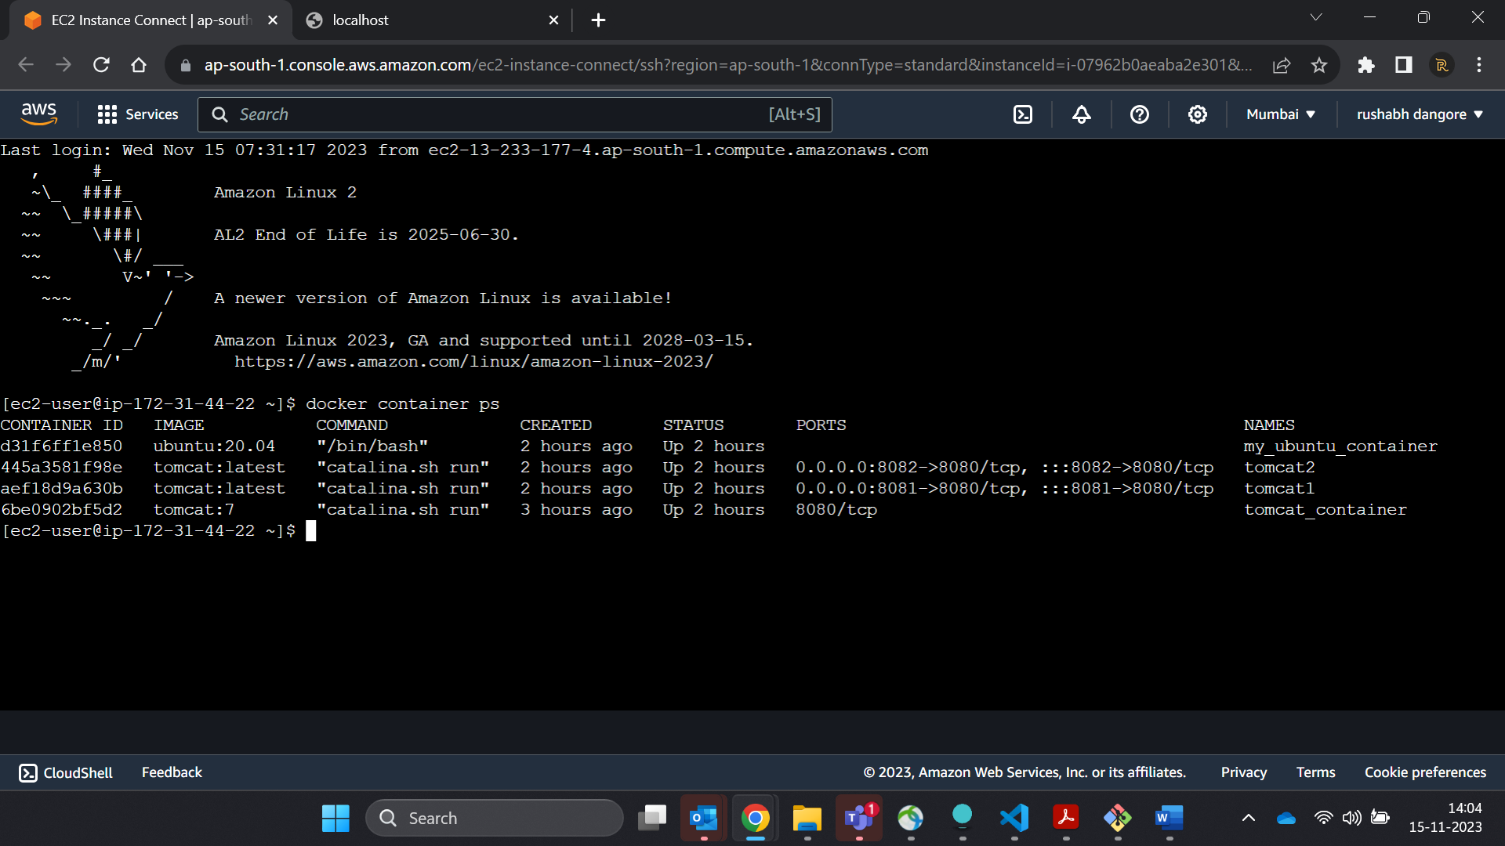

31. Create a new ubuntu container out of the same image as that previous container in attached mode.

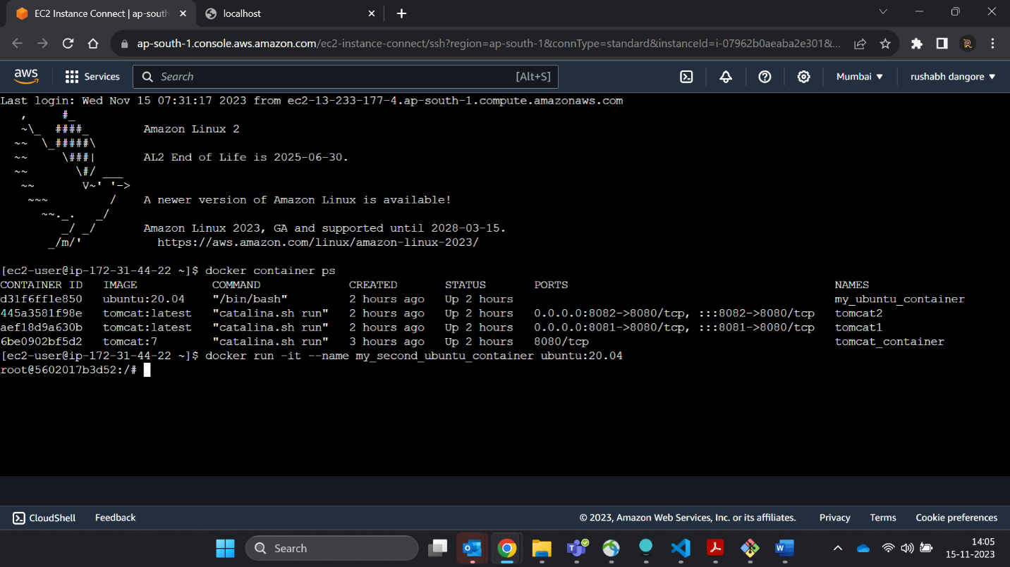

32. Login as a root user

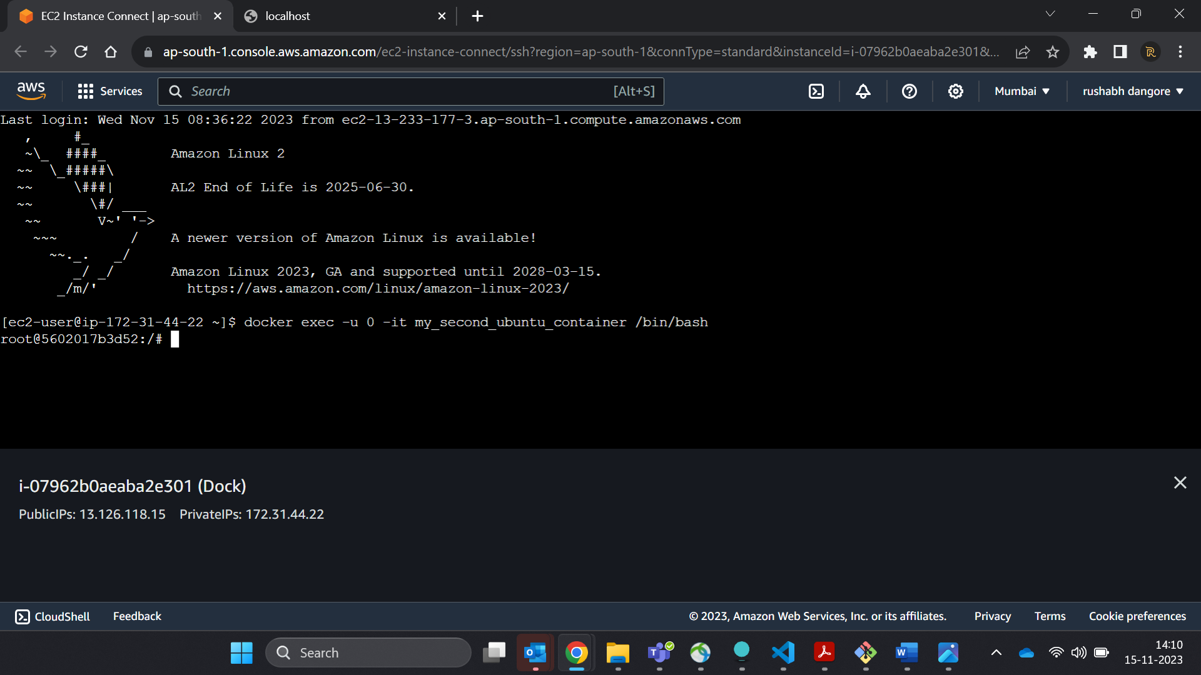

33. Check if you can see the file created in previous container, you will not see the file as well as software that you installed in the previous container. Now kill this Container.

34. Do you have the previous ubuntu container where you created the file and installed the software? If no reapeat step 25 to 29.  
35. Create an Image out of the existing container.

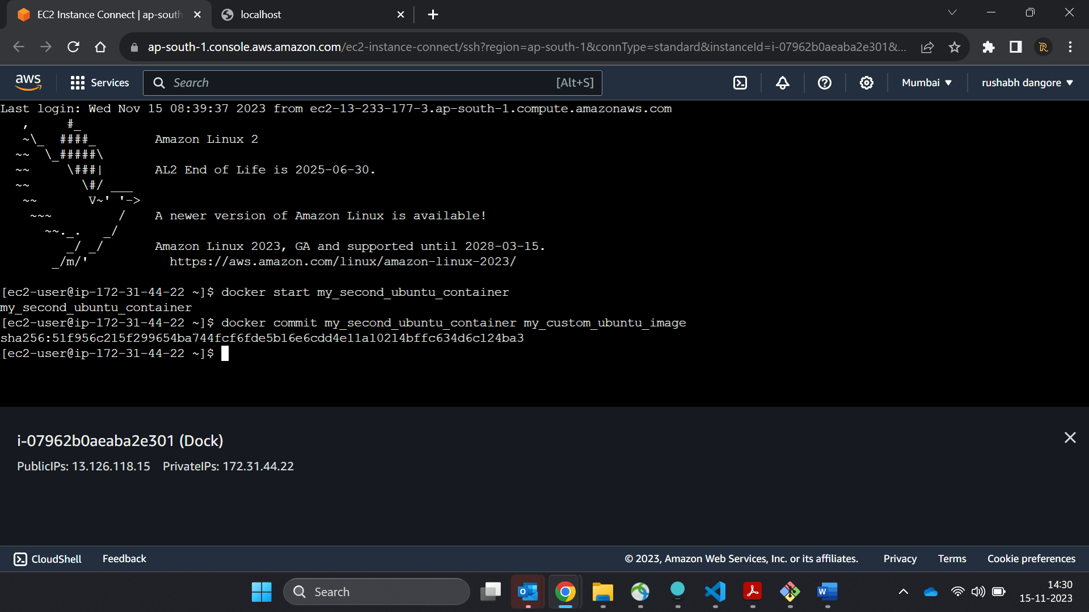  
36. Now Create a Container out of this image and login into it to see if you can see the file and software installed by you in the previous container.

37. Do you have running tomcat container? If yes, Stop it and kill all tomcat container.

